**Problem Statement:-**

You are provided with a file "main.csv" in the input folder. Following operation needs to be provided on the file:-

1. Create an output file "filteredCountry.csv" inside a folder named "output". This file should contain only those records where country contains the word USA.

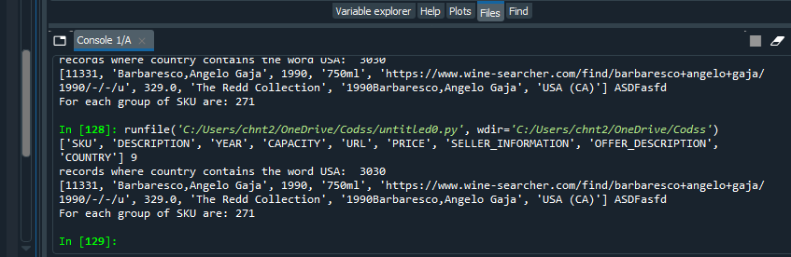

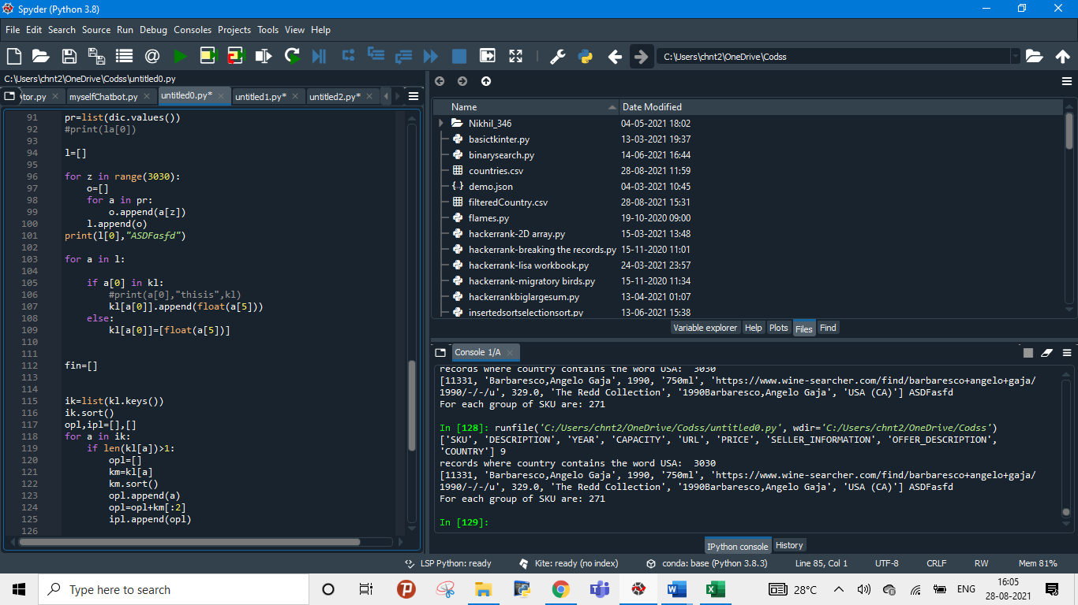

OUTPUT:

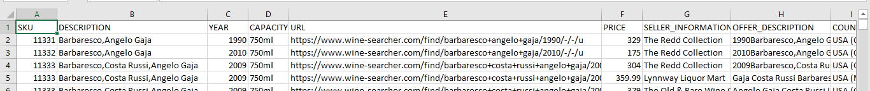

1. Now consider "filteredCountry.csv" as the input file. For each group of "SKU" find 2 minimum prices and store this result in "lowestPrice.csv" inside a folder named "output"

OUTPUT:

